EXPERIMENT – 13
Perform Affine Transformation on the Given Image Using Python and OpenCV
Aim
To perform an affine transformation on an image using Python and OpenCV.
Procedure
- Import the OpenCV and NumPy libraries.
- Read the input image using cv2.imread().
- Check whether the image is loaded successfully.
- Define three points in the original image.
- Define three corresponding destination points.
- Calculate the affine transformation matrix using cv2.getAffineTransform().
- Apply the transformation using cv2.warpAffine().
- Display the original and transformed images.
Program
import cv2
import numpy as np

image = cv2.imread("image.jpg")

if image is None:
print("Image not found!")
else:
rows, cols = image.shape[:2]

points1 = np.float32([
[50, 50],
[200, 50],
[50, 200]
])

points2 = np.float32([
[10, 100],
[200, 50],
[100, 250]
])

matrix = cv2.getAffineTransform(points1, points2)

transformed = cv2.warpAffine(
image, matrix, (cols, rows)
)

cv2.imshow("Original Image", image)
cv2.imshow("Affine Transformation", transformed)

cv2.waitKey(0)
cv2.destroyAllWindows()
Sample Input
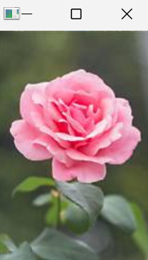
Sample Output
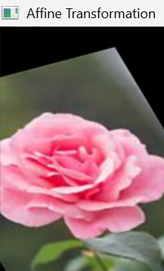
- Affine-transformed image with changed position, orientation, or shape.
Result
Thus, affine transformation was successfully performed on the image using Python and OpenCV.

